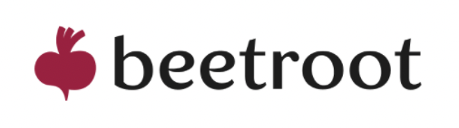

**Test Task for WP Developer**

Themes:

* Custom theme

Features:

* Custom Guttenberg blocks
* Custom Post Types
* Multilingual

Specifications:

* Create a landing page for a creative agency
* You have to develop one page with 4 independent screens
* Each screen should be developed as a custom Gutenberg block
* create custom post type for jobs and team (all additional information should be added as custom fields)
* Each job can be opened as a popup (06_popup_project_details.psd)
* Get in touch button should open the popup with contact information (05_popup_get_in_touch.psd)
* Near the “Get in touch” button should be added, language selector. The website should be presented in English, Sweden, and Ukrainian language versions

Requirements:

* The project should be posted in the Git repository.
* The layout should be responsive
* Use Gulp/Webpack for building assets
* Track time you spent on the task
* The project should be shared via a link with WP Back-office credentials

Bonus tasks:

* Add interactive animations for geometric elements in the background
* Use es6 syntax in js files
* Create custom post types and taxonomies without plugins
* Add support for the Hebrew language with RTL support (https://rtlcss.com/)